
MP3 PLAYER USER’S MANUAL

Digital MP3 PLAYER
USB Storage Disk

Thank you for purchasing this product.

Please read this Manual carefully and make yourself familiar with all functions before using the PLAYER

Display screen 2
Battery 2
Basic function 2
Enter menu 2
Browse Operating 2
Choose function mode 2
Music mode and playback mode 4
Record mode 4
Simple operation 5
EQ (equalizer) mode 5
Voice recording 5
Record in the Record Mode: 6
Select the recording type 6
Play voice recording files 7
Convert ACT recording files to WAV files 7
SYS Set 8
How to enter 8
Brief introduction of each parameter 8
Detail use instruction 8
Use USB disk 9
Please note that this player may not play WMA files; please check the manual in regards to which files can be played. 10
Establish a new file 10
Upgrade player 10
Other setting 11
Delete files (stop playing sub-menu) 11
Playback mode (playing sub-menu) 12
Play speed (playing sub-menu) 12
Repeat mode (playing sub-menu) 12
Special recommend 14
Warning: If forget user name& passwords, you can’t decrypt disk only can cancel it by combine, and it cause you lose all file in the decrypt disk. 15
Troubleshooting 16
Specification 16

Display screen
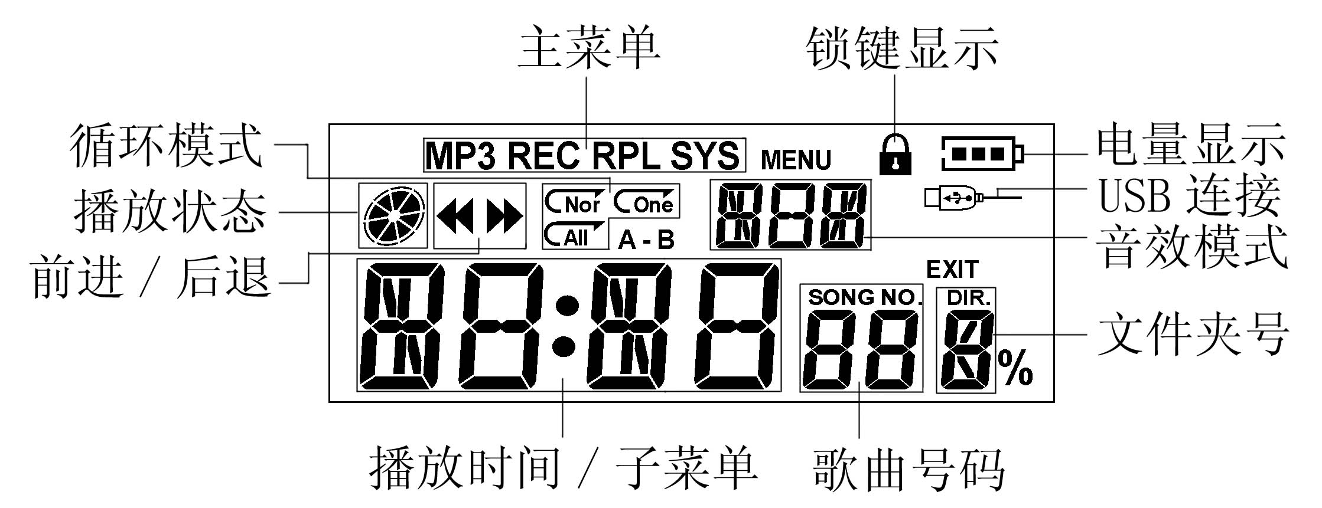
Repeat mode
Main menu
Lock status
The order of song
Battery indication
Play time/ Sub-menu
Folder number
USB connection
EQ mode
Play status
Fast-forward/ reverse

Battery
The player use battery capacity icon with three blocks to indicate the level of battery power remaining.
 When the battery capacity is 1.5V, the battery icon blocks are full, and three blocks will gradually become blank while the using time increased.
 When the battery exhausted, the battery capacity icon will become blank, and need to replace a new one.

Basic function

Enter menu
Enter submenu by pressing ‘Mode’ button. The menu sorted as Main menu (long press to enter in stop status), sub-menu (press to enter when the player is playing), and sub-menu (press to enter when the player has stopped).

Browse Operating
○ Browse the menu or song list to select the one you need
Press LAST button to review the previous and press NEXT button to browse the rest.

○ Fast-forward or fast-rewind while playing music
Press LAST button to fast-rewind, and press NEXT button to fast-forward.

Choose function mode
Choose function mode from main menu
Main menu: (long press Mode button to enter the main menu while under other mode)
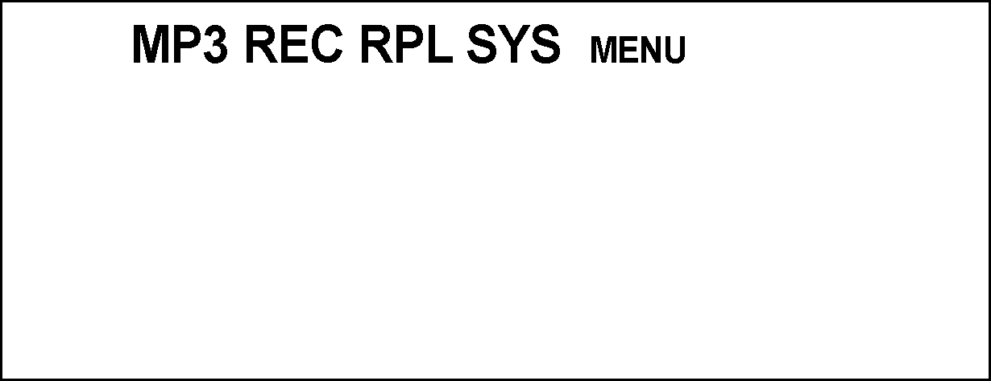
Music mode:
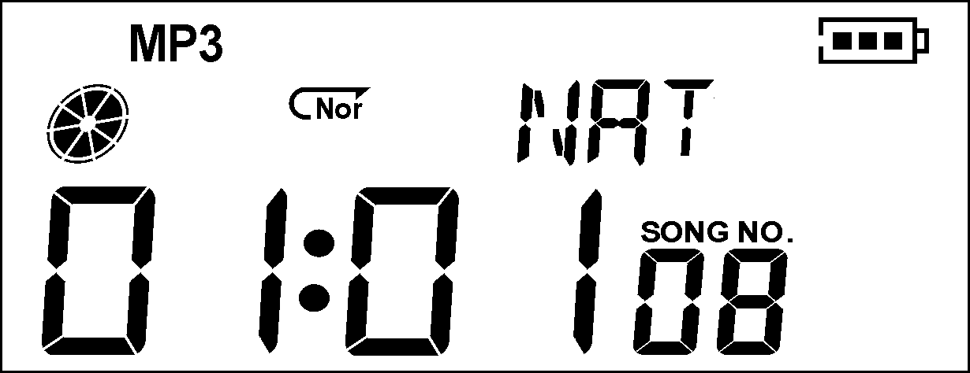
Record mode:
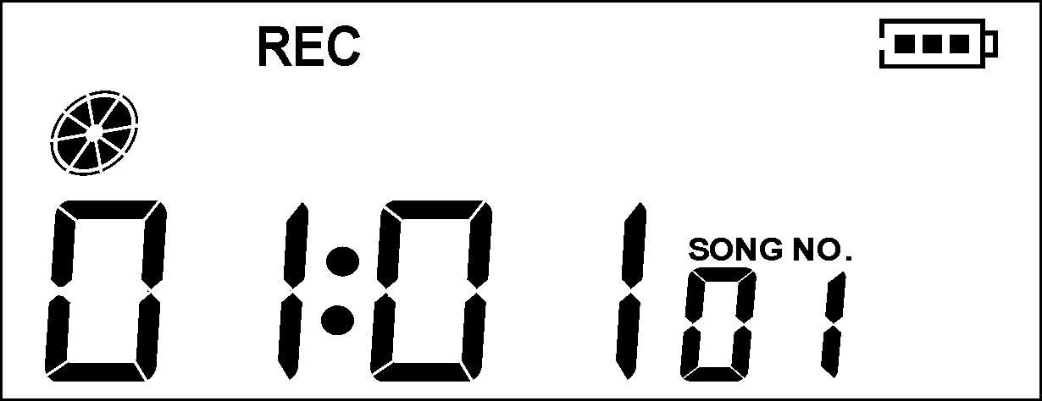
Playback mode:
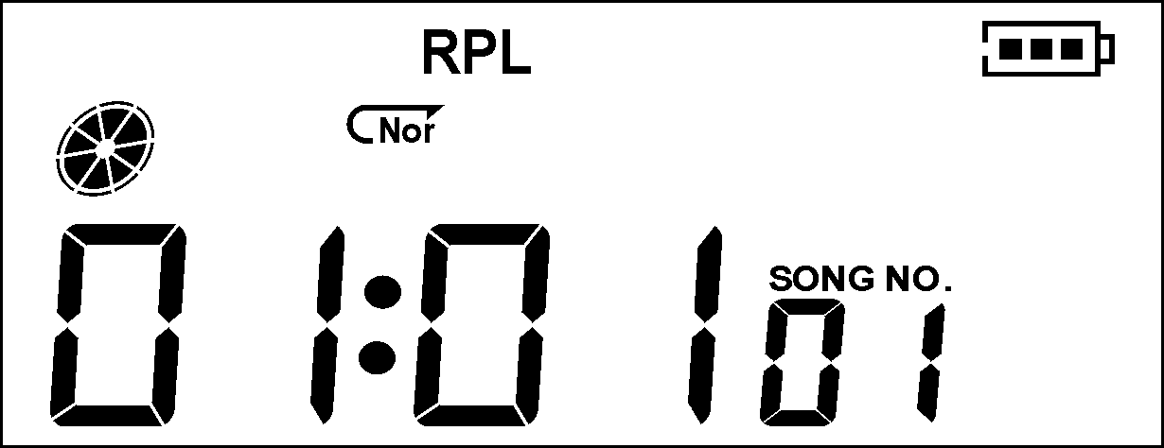
SYS Set:
Connect PC to enter USB mode:
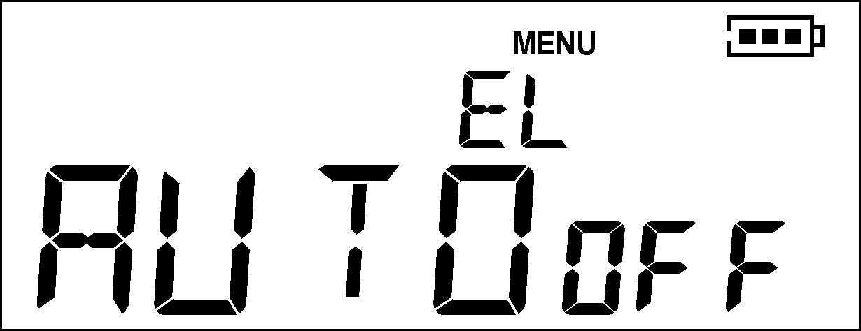
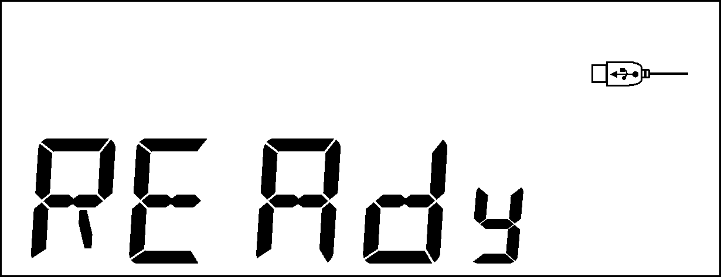

● Volume control
Press VOL- button to decrease volume, and press VOL+ button to increase volume.

● Turn on/off
Long press PLAY button to turn the player on/off.

● Key lock
Slide the HOLD switch to hold position to lock all function buttons.
When choose Hold, the player enters USB mode and displays as below:
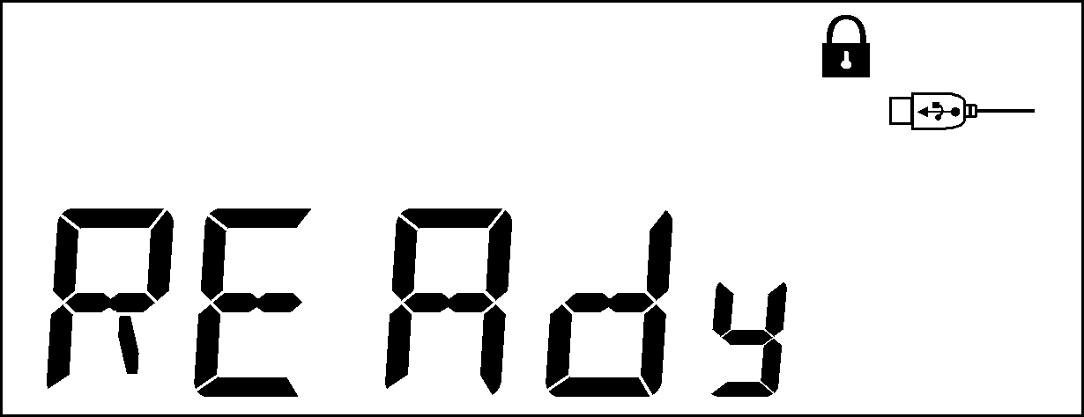
Then, the USB disk is in ‘Write-protection’ condition, no data can input now except Hold is off.

● Press PLAY button: play or stop (while REC could PAUSE); could exit from sub-menu.
● Short/long press REC button: begin recording/pause recording (short press), stop recording (long press)
Press button operation

Music mode and playback mode
Button press | Operating | Stop status | Play status | Playing sub-menu | Stop playing sub-menu
Play | Long press | Shut off | Shut off | Shut off | Shut off
Play | Short press | Play | Stop | Exit menu | Exit menu
Mode | Long press | Enter main menu | Enter main menu | Enter main menu | Enter main menu
Mode | Short press | Enter stop sub-menu | Enter playing sub-menu | Confirm the option or get further | Confirm the option or get further
Next | Push | Next song | Next song play | Menu | Menu
Next | Press and hold | Keep moving forward | Fast-forward | Continue forward | Continue forward
Last | Push | Previous song | Previous song play | Menu | Menu
Last | Press and hold | Continue browsing backward | Fast-rewind | Continue backward | Continue backward
Vol+ | Short press | Volume increase stepwise | Volume increase stepwise | X | X
Vol+ | Hold and press | Gradually increase volume | Gradually increase volume | X | X
Vol- | Short press | Volume decrease stepwise | Volume decrease stepwise | X | X
Vol- | Press and hold | Volume gradually decrease | Volume gradually decrease | X | X
REC/A-B | Short press | Enter Record Mode and start record | Enter A-B replay status. | X | Enter Record Mode and start record
REC/A-B | Long press | Enter Record Mode and start record | Enter A-B replay status. | X | Enter Record Mode and start record

Record mode
Button press | Operating | Stop status | Recording status
Play | Long press | Shut off | Stop recording
Play | Short press | Start recording | Pause recording
Mode | Long press | Enter main menu | X
Mode | Short press | Enter Record sub-menu | X
REC/A-B | Short press | Start recording | Pause recording
REC/A-B | Long press | Start recording | Stop recording

Simple operation
1. Connecting earphone  Plug the earphone into the player’s earphone jack. | 2. Ensure the HOLD button not in hold position;  Check no lock icon displays on the screen;  Make sure HOLD is OFF;  Check the key-press function.
3. Long press PLAY button to turn the MP3 player on and enter Music Mode, short press PLAY button to play music. | 4. Select songs  Last button: select the previous song  Next button: select the next song
5. Volume control  VOL+: volume increase  VOL－: volume decrease | Note  - Once the HOLD button is activated, it will disable all other function buttons.  - Except in playback mode or record mode, the player auto off while ‘SYS Set/Shut off setting/Power save mode’.

EQ (equalizer) mode
- When the player is playing | 2． Press Mode button to enter playing sub-menu.  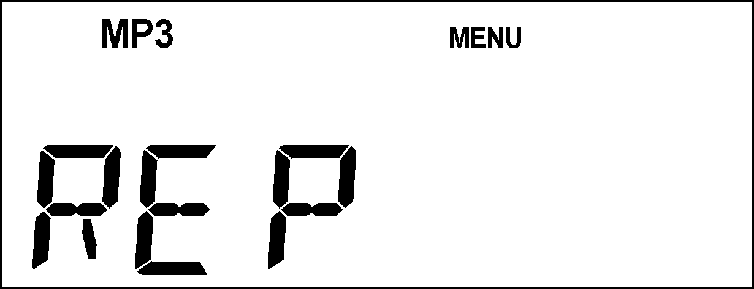
3． Push Next button and choose EQ Mode option. | 4． Press Mode button to enter EQ Mode menu.
5． Push Next button to choose, press Mode button to confirm the option. | 6． EQ (Equalizer) explanation:  （Natural）  （Rock）  （Pop）  （Classical）  （Soft）  （Jazz）  （DBB）

Voice recording
Ensure sufficient battery capacity during recording.
The player support 99 voice recording files storage in each directory.

Record in the Record Mode:
- Enter main menu | - Push Next button to choose Record Mode.
3．Press Mode button to enter Record Mode. | 4. Press Play button to start recording.
The recording voice will be saved in the present directory set by ‘main menu/sub-menu while in stop status’.
If the screen displays ‘Out of Space’, which indicates the current directory has already saved 99 voice recording files, the user need to change to a new directory.
Only Play button and REC/A-B button can work while in recording process.

Select the recording type
- In the stop recording condition. | - Press Mode button to enter recording sub-menu.
- Push Next button to choose Record Mode sub-menu option.  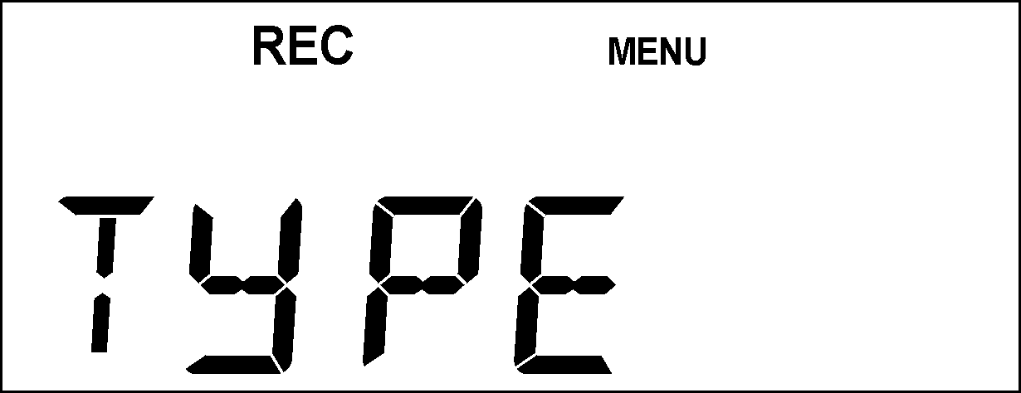 | - Press Mode button to enter the sub-menu.  In the Record Mode sub-menu condition:  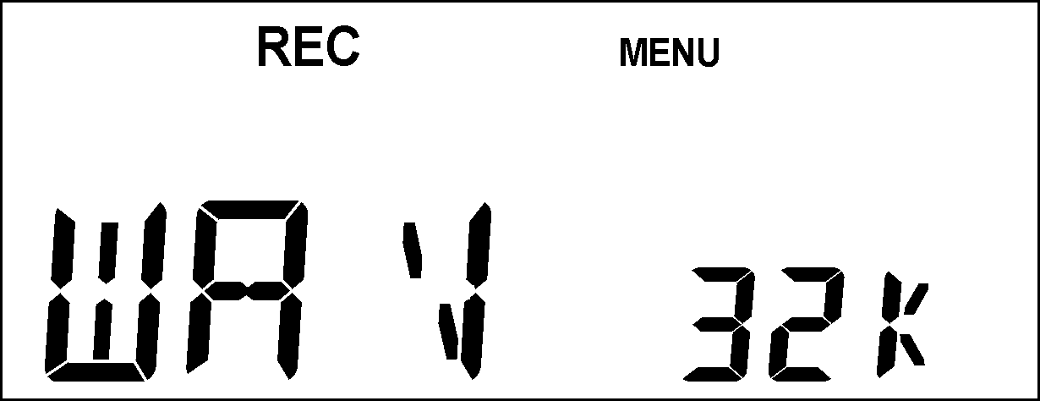
- Push Next button to choose suitable record mode. | - Press Mode button to confirm the option.
- Press Play button to start recording. | - Record Mode:  32K WAV: fine sound recording, wav format.  8K ACT: long time recording, act format, general sound quality.  32K VOR: fine sound control, wav format (sound-control recording, pause recording when no sound is heard.)  8K VOR: long time sound-control, act format.

Play voice recording files
1．Enter main menu option | - Push Next button to select Playback Mode.  Playback Mode:
3．Press Mode button to enter Playback Mode.  Playback Mode | 4．Press Play button again to start playing.
5．Select voice recording files:  Last button: select the previous voice recording files.  Next button: select the next voice recording file. | 6．Volume control:  VOL+: volume increase  VOL－: volume decrease

Convert ACT recording files to WAV files
Use the accessory install driver to convert ACT format file to WAV format.
1. Run ‘Sound Converter’ program; click ‘OPEN’ button.
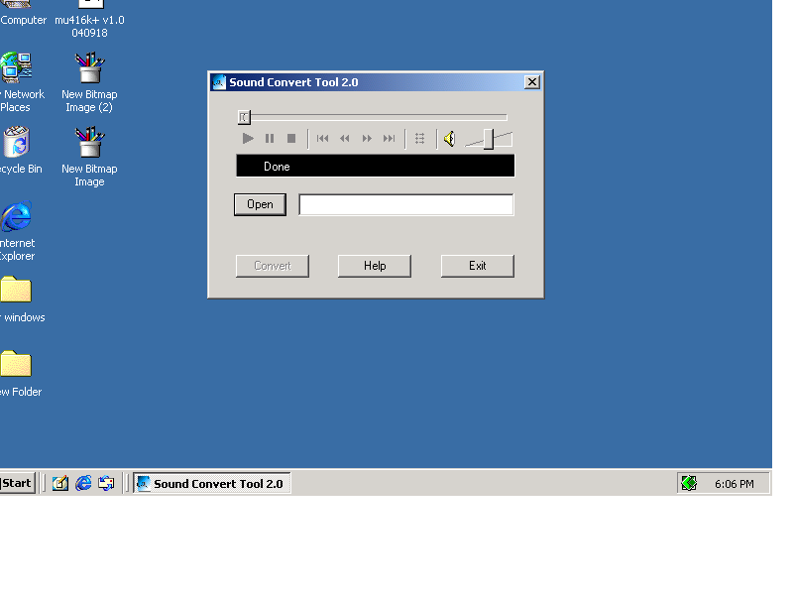
2. Choose ACT files.
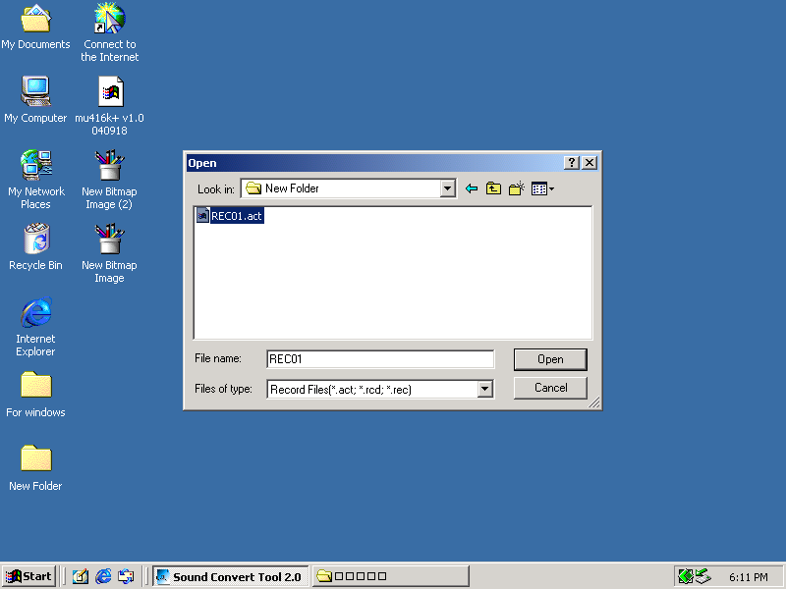
3. Click ‘Convert’ button, the system begins the format conversion.
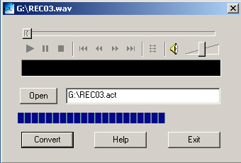

Except for the format conversion function, the player still can play WAV files and MP3 files.

SYS Set

How to enter
Set system parameters here, each option will change as the firmware Upgraded.
- Enter main menu. | - Push Next button and choose ‘SYS Set’.
- Press Mode button to enter ‘SYS Set’ sub-menu.

Brief introduction of each parameter
Backlight timing | Backlight duration after the backlight is activated, and with no button depressed during this time.
Shutoff timing | Set countdown timer (by minutes), the player will shut off when the remaining countdown time is zero.
Linking mode | for ‘Privacy Spaces’ option.
Memory | Check the memory size and the remaining memory.
Firmware Version | Display the player’s FM version.
Firmware Upgrade | Special for firmware upgrading.
Exit | Exit the interface.

Detail use instruction
○ ‘power off timing’ set
- SYS Set mode | - Push Next button and choose power off Timing.  Power off timing:  
- Press Mode button to get into power off Timing mode.  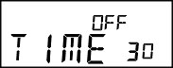 | - Push Next/Last button to adjust time.
- Press Mode button to exit after adjustment.
○ Linking Mode
Practical operation please refers to the EQ Mode setting.
Some operation sys.(windows 2K Sp4 or previous version)can’ t support USB disk with 2 disks, so if use “Privacy Space” function, need to choose either of “Single ordinary disk” or “Single encrypt disk” in advance, otherwise no disk is available when linking with pc.
Nor means single ordinary disk;
Multi means multi general disk;
Encrypt means single encrypt disk
○ Memory
The number shows the total memory size of the disk, the percentage shows the already used memory percent.
○ Firmware version
The screen displays the current firmware version of the player.
○ Firmware Upgrade
Need to enter FM Upgrade mode to upgrade firmware.
Hint-skill: After finishing set by pressing Mode button, can exit menu quickly by keeping short time pressing Play button and it works for all over menu.

Use USB disk
The player support standard USB disk function, also able to support Windows98 (install driver required), Windows 2K or above (no need of install driver), Mac OS X 10.3 or above, Linux Redhat 8.0 or above.
The player can be powered from a USB port, so it can play without battery. In ‘Standby Status’, press Mode button to return to the main menu, and choose and enter Woking mode.
The player support Suspend Mode.
How to connect with a PC? Turn the player on and insert the USB cable to a PC port, the player will enter mode 1 as described below.
After linking with PC, the player displays as following:
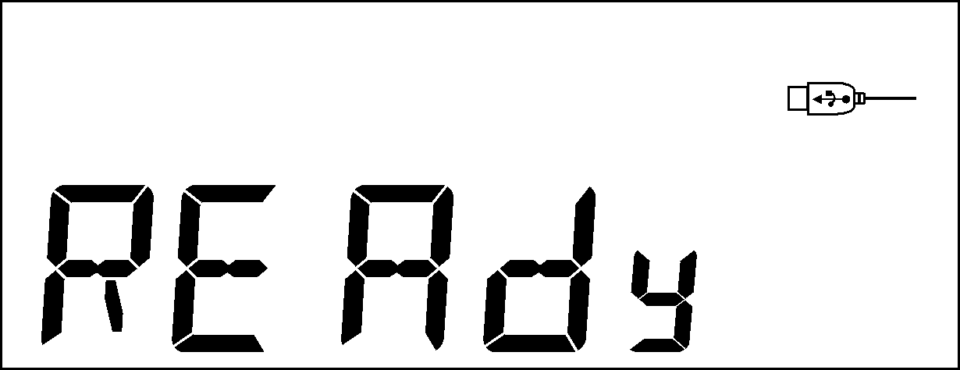

Post Installation Instructions

After installation of the MP3 player on Windows 98/ME/2000/XP the player requires an initial format to make sure it is correctly set:

- The MP3 player should be displayed as `Removable Disk` under My Computer, when found `RIGHT CLICK` on the MP3 and select format.

- A menu will appear, select format and a format box will then appear.

- Click start and the format will begin (do not select quick format).

- The MP3 is then ready to use.

- To transfer MP3 files to the MP3 player double click the removable disk icon in My Computer and then `drag and drop` the required files into the opened window.

Please note that this player may not play WMA files; please check the manual in regards to which files can be played.

Establish a new file
The player user can establish 9 root folders in the flash disk.

Upgrade player
The player is able to upgrade or maintain the system firmware by using software tool in PC.
1. To run upgrade tool ‘MP3 Player Upgrade’ in the PC, then click ‘Select new firmware file’ button.
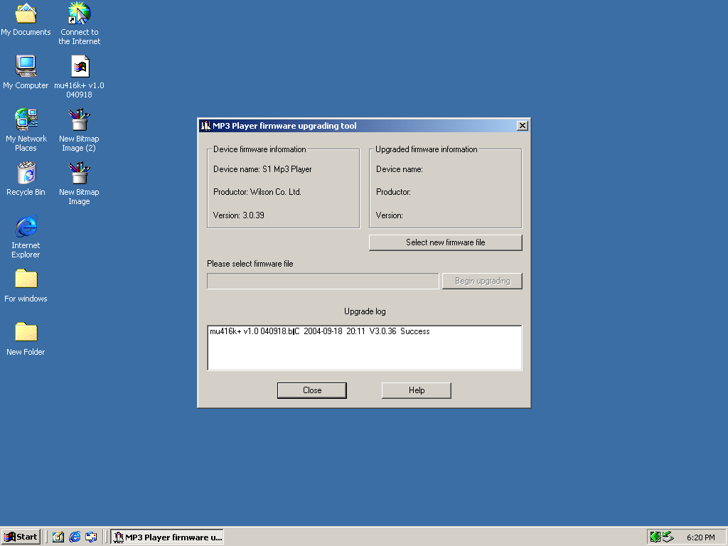
2. Select new firmware program (can find accessory CD or download from the manufacturer’s website).
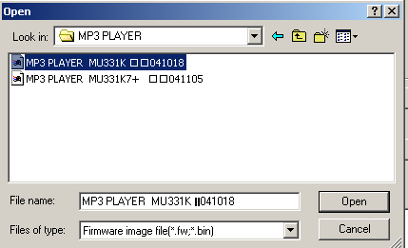
3. Click ‘Start Upgrade’ button to start upgrading operation.
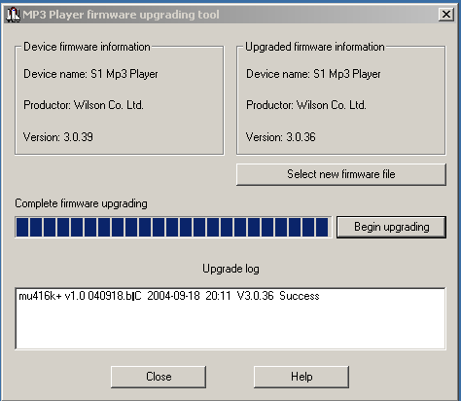
4. Upgrading successfully, the player screen displays as following:
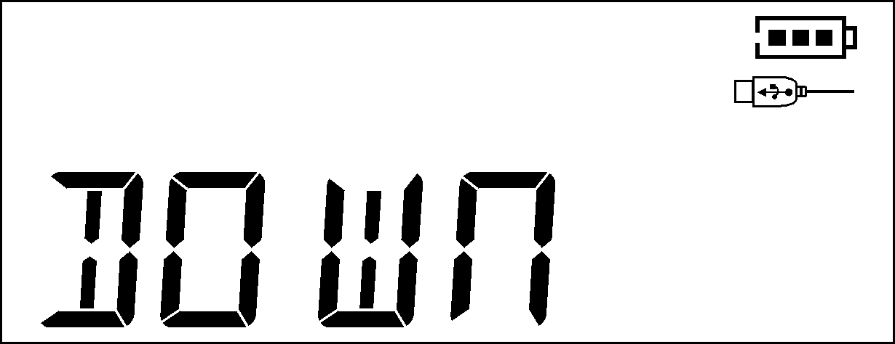
FW Upgrade is used for improving and optimizing the player performance. Not to upgrade firmware won’t affect the normal function of the player.
Read the instruction carefully before real FW upgrading, any illegal operation may cause unit can’t work normal, so the work must be performed by person with basic computer knowledge.
The FM upgrading software used for this player doesn’t match to other series of players, and vice versa.

Other setting

Delete files (stop playing sub-menu)
The player is able to delete relative files in Music Mode or Playback Mode.
1．When in Stop status | 2．Press Mode button to enter sub-menu while in stop status.  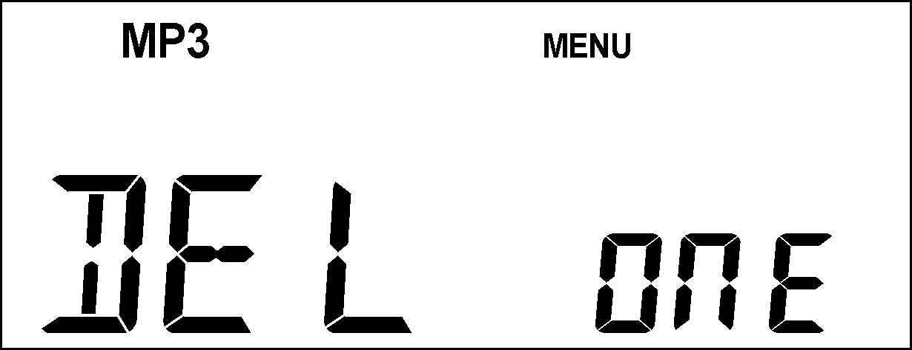
3．Press Mode button and choose Delete Mode.  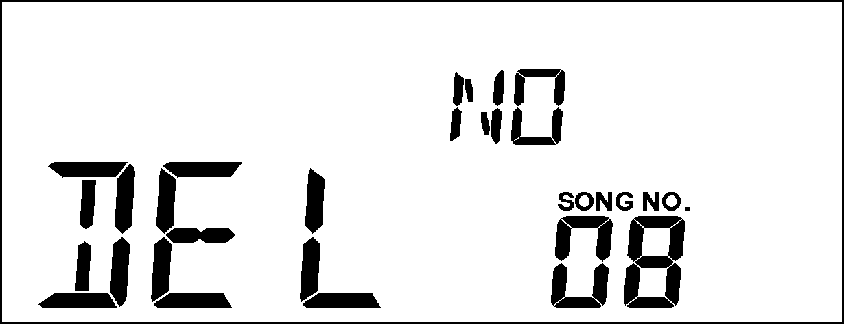 | 4．Push Next button to switch ‘NO’ to ‘YES’.  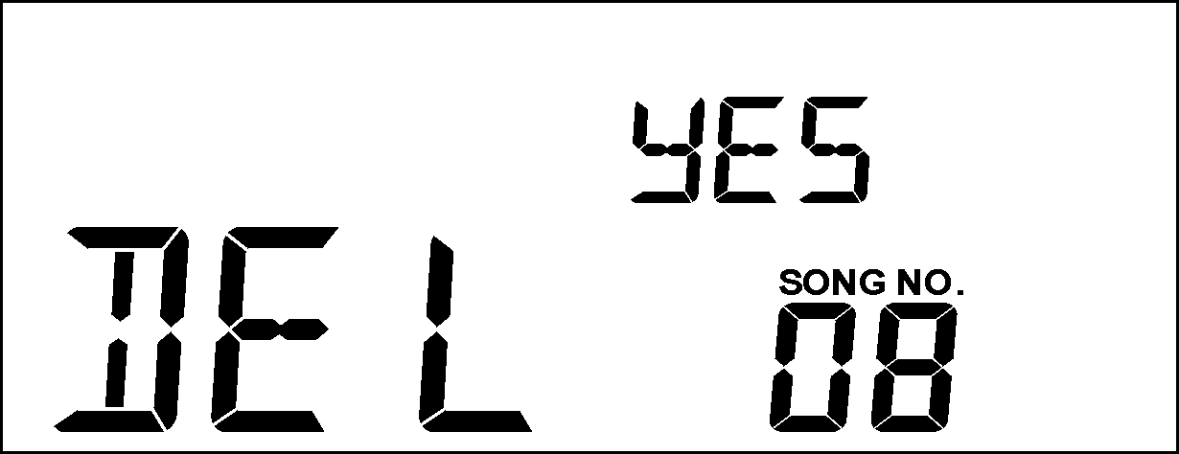
5．Press Mode button to confirm deletion.

By choosing ‘Delete All’ to delete all relative files saved in the present directory. (Such as to delete all files under Music Mode will only delete music files, unable to delete recording files.)
Note: when files are deleted from a removable disk on computer, should ensure player exit PC safely before unplugging the USB cable, otherwise the file can not be deleted.

Playback mode (playing sub-menu)
When the player is playing MP3 files or voice recording files, the user can select various playback mode (such as single repeat or loop repeat).
Choose the first option Playback Mode in sub-menu of playing menu, after you confirmed your option, the player will play as set before.

○ REPEAT
(Normal repeat） | Play tracks in sequent.
 (Single repeat) | Consecutively repeat the current track.
(Loop repeat) | Consecutively repeat playing all tracks.

Play speed (playing sub-menu)
Can choose playing speed (Speed Up/ Slow Down) when playing music (Only MP3 format file) and Rec. file, but tone keep same.
1．When the player is playing music. | 2．Press the Mode button into playing sub-men.
3．Push Next button and choose Play Speed options menu.  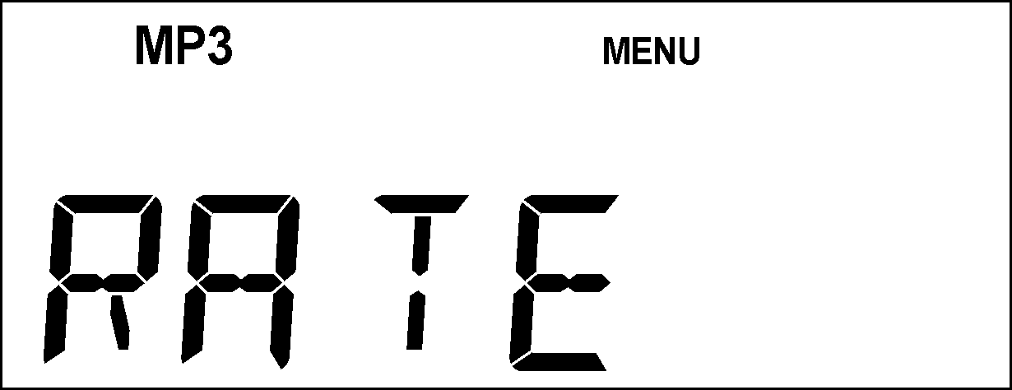 | 4．Press Mode button into Play Speed options menu.  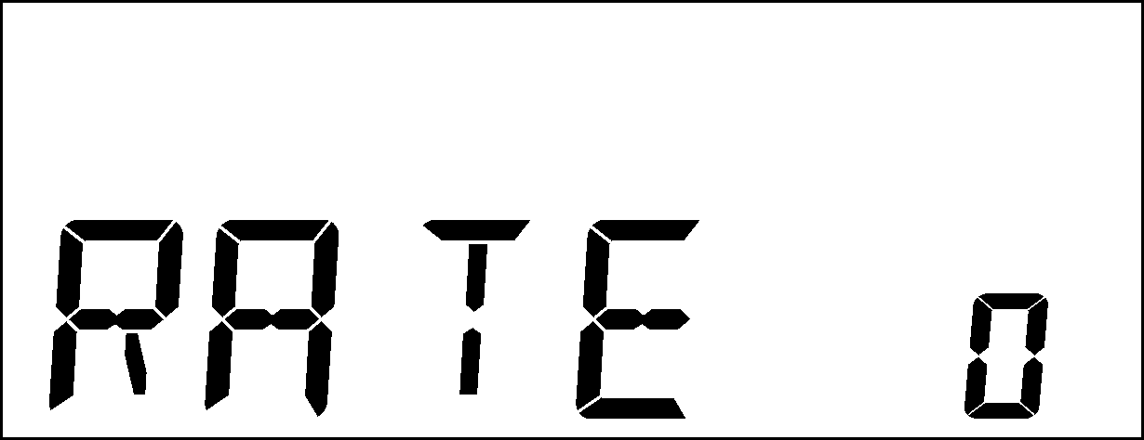
5．Push Next button, the player will speed up, or push Last button will slow down. | 6．Note:  This enactment will work to all songs until reset next time.

Repeat mode (playing sub-menu)
- Press REC/A-B button to enter Repeat Mode.
Practical operation is described as below.
■ Enter playing sub-menu:

○ A-B Replay
1．When the player is playing music or playing voice recording files. | 2． Press Mode button into sub-menu.
3. Push Next button and choose Repeat Mode options menu.  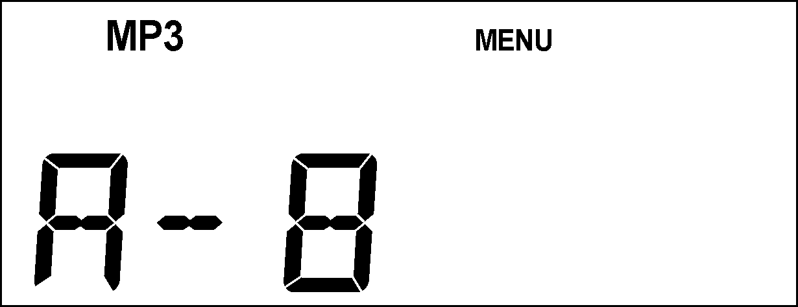 | 4. Press Mode button into Repeat Mode.  Repeat Mode:  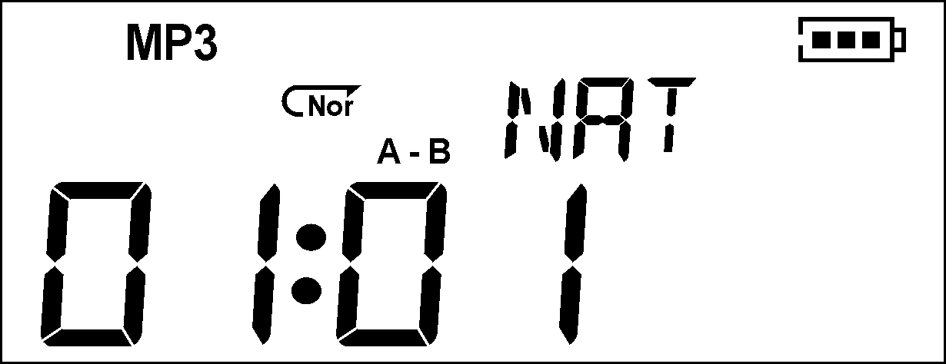  Icon ‘A-‘starts blinking, and then can confirm the starting of segment.
5. Push Next button to confirm the A point.  Icon ‘B-‘starts blinking, and then can confirm the end of segment. | 6. Push Next button to confirm B point.  The replay icon ‘‘stops blinking, then keep replaying segment A-B, and exit when finish running times preset. You can reset A point by pressing Last button under the same mode. (Playing time please refer to ‘Replay Time’ described below.)
In Repeat Mode, press VOL+ button or VOL- button to set the ‘Play Speed’.

○ Follow and read function (no such function in playback mode)
1．A-B segment repeat status. | 2．Push Next button and choose Follow and read mode.  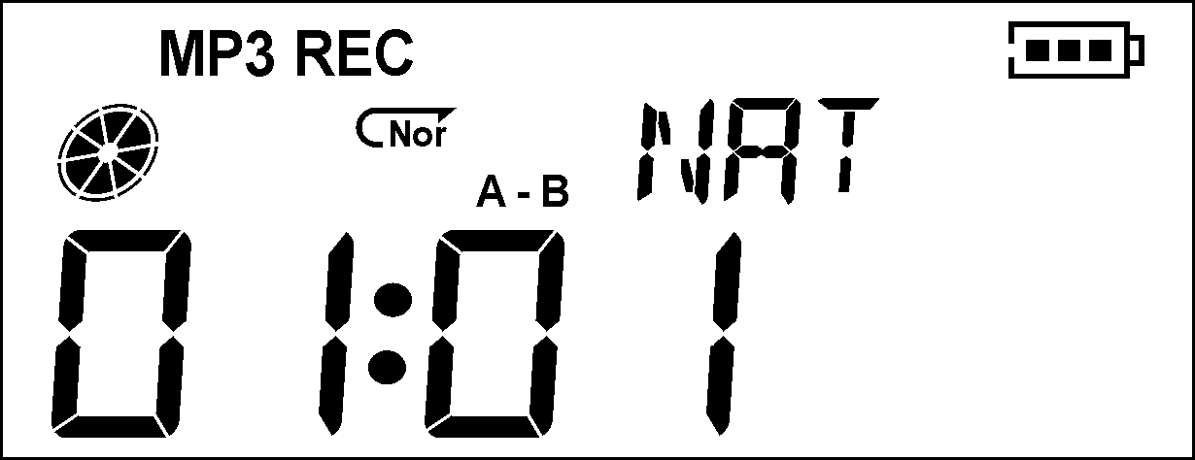
3．The ‘MP3’ and ‘REC’ icon goes on simultaneously, now the player starts record your voice, maximum recording time is the same as A-B replay time. | 4．The player will terminate A-B replay and returns to the track segment when time is up. Now only ‘MP3’ icon lit in the main menu, and you can push Next button to enter Contrast Mode.

Return to A-B Replay mode by pushing Last button in such status.

○ Contrast function (no such function in playback mode)
1． Enter contrast mode, only ‘MP3’ icon lit in the main menu, now the player plays the track segment. | 2．After complete playing of track segment, the ‘MP3’ icon and ‘RPL’ icon will light simultaneously, and the player begins playing recorded segment.  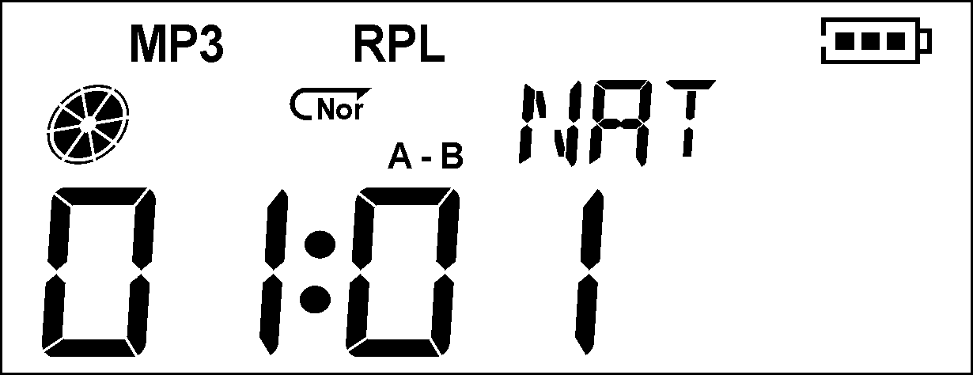
3．After playing the recorded segment, the player starts playing the track segment, A-B replay will continue (not limited to the Repeat Time setting) until pressing Mode button to exit.
Return to the Follow and read mode by pushing Last button in such status.
Exit the Repeat Mode by depressing the Mode button under the above three status.

Special recommend
Privacy Spaces
Generally MP3 player users worry about the risk of loss of confidential data, as they unwilling to let others discover their private data, so they have to delete those private files before lending the MP3 player to friends, which really cause a big problem.
From now on, our player’s file encryption function totally resolves this problem.
User can use the accessory tools to divide USB disk in 2 parts by random scale, (you can find two disk icons on the computer screen, for Windows 2K version need to install SP4, otherwise only one disk icon can be observed, then the user need to enter SYS Set/Linking Mode to choose ‘Single ordinary disk’ or ‘Single encrypt disk’ to find the other disk icon, and encrypt one file to protect its content (also can choose without encrypting, divide as 2 disks), then no one can have access to the private files without password, such is for ‘Privacy Spaces’ fantastic function.
- Linking the player with PC.
- Run the accessory install driver ‘MP3 Player Disk Tool’.
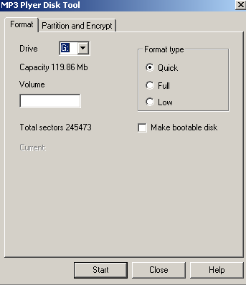
- First You will see a format tool, then choose ‘Divide & Encrypt’ option to choose a suitable memory size for the encrypt disk, and choose ‘User Name & Password’ option to input User Name & Password, and reconfirm password by inputting password again. Then click ‘Start’ button to start dividing spaces.
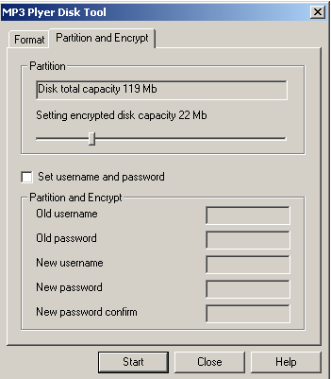
- When finishing you get hints as image:
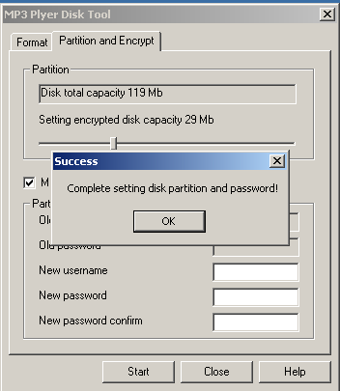
- Click ‘Confirm’ button, then reboot PC.
- You can see 2 disks after reboot (for Windows 2K SP4 version or previous only see 1 disk), click encryption disk (second one), you will get 3 files, 2 are hidden file, 1 is RdiskDecrypt.exe file, and the disk space is only 30K.
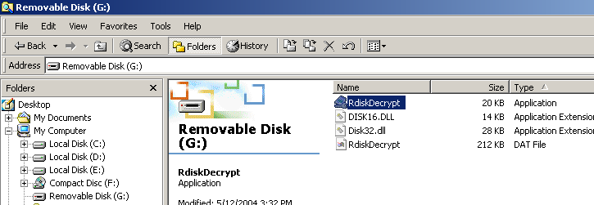
- To run EXE files ‘RdiskDecrypt.exe', input user name & password in the dialogue box to open the disk, then you can copy and paste files in the disk.
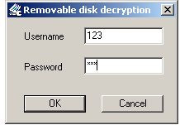
- You must input the user name and password to open the encryption disk when connecting the PC.
Note: Divide 1 disk into 2 will delete all data, please backup in advance before combining 2 disks as 1.

Warning: If forget user name& passwords, you can’t decrypt disk only can cancel it by combine, and it cause you lose all file in the decrypt disk.

Troubleshooting
No power | Check battery installation  Verify the player is on
No sound from the earphone | Please verify volume level is not 0 and earphone connection is secure  check cleanliness of earphone  A damaged MP3 will create different levels of noise and cannot play music. Please ensure document integrity
Strange word in LCD screen | Make sure of the right language selected.
Cannot download music normally | Check any damage to USB cable, whether connection is secure and correct.  Is driver program installed properly?  Check for sufficient remaining memory

Specification
Display screen | Segment (4x32) LCD display
PC connection | High speed USB2.0(FS) (read 1000K Byte, write 800K Byte)
Memory | Flash memory: 32M~1G
Power supply | 1 AAA (No 7) Alkaline battery
Power supply | Maximum play time 8 hours
Recording | Sampling rate | 8KHz
Recording | Music format | WAV (32K bps), ACT (8K bps)
MP3、WMA | Maximum earphone output | (L) 10mW+(R ) 10mW (32Ohm)
MP3、WMA | MP3 bit rate | 8K bps – 320K bps
MP3、WMA | WMA, WMV, ASF bit rate | 5K bps – 384K bps
MP3、WMA | Frequency response | 20Hz至20KHz
MP3、WMA | Signal Noise Ratio | 85dB
Music format | MP1, MP2, MP3, WMA
Operating temperature range | -5 ~ 40℃
OS support | Windows98/SE/ME/2K/XP、Mac OS 10.X or above



