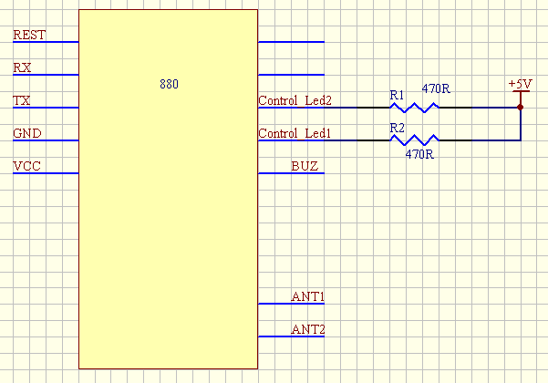
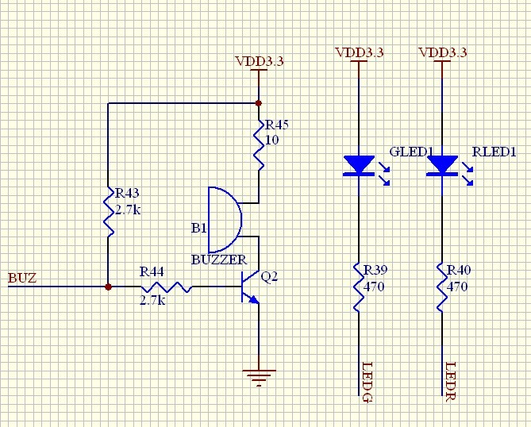
Usually
Pin Control_Led2 is 5V voltage
Pin Control_Led1 is 0V voltage
Pin BUZ is 0V voltage

When I send Control_Led2 command(AA 00 03 88 18 01 92 BB) ,
Pin control_Led2 LED Status :OFF-ON-OFF

When I send Control_Led1 command(AA 00 03 87 18 01 9D BB) ,
Pin control_Led1 LED Status :ON-OFF-ON

